Asher Scott
Data 205
CRN 33155
Capstone Project: Evaluating Washington, D.C. as a Disability-Friendly City

1. Introduction
The Americans with Disabilities Act (ADA) was signed into law over three decades ago. It was a landmark civil rights achievement, establishing clear mandates for accessible public infrastructure. In practice, however, legislative compliance does not always translate to lived reality. For a person using a wheelchair, a single broken curb ramp or a missing audible pedestrian signal can turn a routine trip into an impassable barrier.
This project stems from a fundamental question: does the infrastructure of the nation’s capital truly serve its disabled residents, or does it merely exist on paper? For my capstone project, I set out to empirically determine whether Washington, D.C., qualifies as a “disability-friendly city.” Rather than relying on general perceptions or high-level policy documents, I used spatial analysis and statistical computing to quantify the gap between ADA mandates and real-world conditions.
My hypothesis was that while D.C. has installed vast amounts of accessibility infrastructure—ramps, bus stops, sidewalks, and audible signals—significant gaps in maintenance, distribution, and prioritization likely prevent the city from being truly accessible. This report details my methodology, analysis of demographic and infrastructure data, key findings regarding maintenance failures and transit access, and my final conclusions on the state of D.C.’s accessibility.

2. Data, Goals, and Tools
Data Sources
To answer my research question, I could not rely on a single dataset. Instead, I integrated twelve distinct datasets from D.C.’s Open Data Portal (opendata.dc.gov), with most updated as recently as 2024. I combined demographic information from the American Community Survey (ACS) with geospatial infrastructure layers. The core datasets included:
- Demographic & Socioeconomic: ACS 5-Year Social and Economic Characteristics (disability prevalence, age, income by ward).
- Transit Infrastructure: ADA Bus Stops, Metro Stations (Regional).
- Pedestrian Infrastructure: ADA Curb Ramps, Sidewalk Condition Assessment, ADA Audible Pedestrian Signals (APS), and ADA Barriers in the Public Right-of-Way (PROW).
A critical limitation is that the CDC prohibits publishing exact point-level location data for specific disability types due to privacy guidelines. I mitigated this by using ward and neighborhood centroids as proxies, clearly noting this limitation in my conclusions.

Goals
My primary goal was to produce an evidence-based answer to whether D.C. is disability-friendly. Secondary goals included: (1) identifying which infrastructure types have the highest noncompliance rates, (2) quantifying how far disabled residents live from transit and from physical barriers, and (3) determining whether socioeconomic factors correlate with infrastructure quality. The value of this work is diagnostic and advocacy-oriented—providing city planners and disability advocates with data-driven evidence of where gaps exist and initiative needs to take place.

Tools and Methods
My primary tool was Google Colab (Python with pandas, geopandas, numpy, matplotlib, seaborn, and scipy.stats), supplemented by QGIS for spatial analysis and mapping. I structured the project into four milestones:
- Data Structuring: joining ACS ward data with infrastructure layers.
- Core Compliance Analysis: identifying failing infrastructure.
- Accessibility & Distance Metrics: calculating travel distances to transit and distances to barriers.
- Finalization: visualization and synthesis.

3. Summary of Data Cleaning and Pre-Processing
Cleaning and preprocessing consumed approximately 40% of my total project time. I will highlight the most important elements here; full details and code are available in my GitHub repository.
Curb Ramp and Sidewalk Data
The curb ramp dataset contained over 34,000 records with a CONDITION column containing values such as “Good,” “Fair,” “Non-Compliant,” and “Missing.” I filtered out null values and generated frequency counts. I then created a binary compliance variable: “Compliant” included Good and Fair; “Non-Compliant” included Missing and Non-Compliant.
The sidewalk dataset had over 24,000 records with SCI_CATEGORY (Excellent, Good, Fair, Poor, Failed) and MAINTENANCEPRIORITY (High, Medium, Low, None). I filled in missing SCI_CATEGORYvalues as “Missing” and aggregated total linear feet by condition. I also cross-tabulated condition against maintenance priority, which revealed that some failed sidewalks were labeled low or medium priority while excellent sidewalks had no priority assigned at all.
Barriers Data
The ADA Barriers dataset was the most challenging to clean. The raw ASSET_TYPE column contained 479 unique text strings—for example, “Missing Sidewalk,” “Vertical Displacement,” “Cracked Sidewalk,” “Pole in Path,” and many others. I wrote a custom grouping function using string pattern matching to collapse these into eleven standardized categories: NO SIDEWALK, VERTICAL DISPLACEMENT, HORIZONTAL DISPLACEMENT, CRACKED SIDEWALK, POOR PAR, POLE, TRASH, POOR WIDTH, SIGN, VEGETATION OBSTRUCTION, and MISCELLANEOUS.
I then defined a three-tier impact classification: HIGH IMPACT (NO SIDEWALK, VERTICAL DISPLACEMENT, POLE, POOR WIDTH), MEDIUM IMPACT (CRACKED SIDEWALK, POOR PAR, HORIZONTAL DISPLACEMENT, VEGETATION OBSTRUCTION), and LOW IMPACT (SIGN, TRASH). This preprocessing was essential; without it, the 479 raw categories would have been unusable for any meaningful analysis.
ACS Data
The ACS Social and Economic datasets were ward-level tables with numerous columns (over 150 each). I extracted specific columns: total population (DP02_0071E), disabled population (DP02_0072E), disability rates by age group, and median household income (DP03_0062E). I merged these on ward identifiers (GEOID / NAMELSAD), which required converting ward numbers to a consistent format (e.g., “1” vs. “Ward 1”).
4. Basic Descriptive Statistics
Disability Demographics
Disability is not evenly distributed across age groups. Using ACS data:
- Under 18: 4.5% (approx. 5,700 children)
- Working-age (18–64): 8.8% (approx. 40,000 people) – the largest total group
- Seniors (65+): 42.3% (approx. 27,000 people) – the most disproportionately affected group
By disability type, ambulatory (mobility) disabilities are the most common, affecting approximately 40,000 residents, followed by cognitive (approx. 33,000) and self-care (approx. 28,000). This finding directly informed my analysis priorities: because mobility limitations are the most prevalent, factors like curb ramp compliance, smooth sidewalks, and short travel distances are not merely helpful—they are the most essential features for the largest share of the disabled population.
Infrastructure Overview
The city maintains over 34,000 curb ramps, over 24,000 sidewalk segments, and thousands of bus stops and APS signals. However, raw counts alone are misleading. For example, only 43% of curb ramps were compliant (good or fair condition); 57% were either missing or non-compliant. Sidewalk data showed over 1.04 million linear feet rated “FAILED,” indicating severe cracks, obstructions, or uneven surfaces. The median distance from a ward centroid to the nearest ADA-compliant bus stop ranged from approximately 60 meters to over 300 meters depending on the ward. The median distance to the nearest Metro station was approximately 1,038 meters—over half a mile.

5. Description of the Final Data Product
My final data product is a ward-level ADA compliance scoring system, supported by spatial distance metrics and barrier encounter probabilities. I will present the two most important outputs: a summary table of ward grades and a bar chart of compliance scores. Both were constructed manually by aggregating compliance percentages, normalizing scores, and applying a weighting scheme.

Table 1: Ward ADA Compliance Scores and Asset-Level Breakdown
Note: I constructed this table manually in one of my repository Notebooks by calculating compliance percentages for each asset type per ward, then computing a weighted average.

WARD | Bus_Stops | Bus_Quality_Score | Curb_Ramps | Curb_Quality_Score | APS_Signals | APS_Quality_Score | Sidewalk_Segments | Sidewalk_Quality_Score | Raw_Score | Final_Score | Grade
8.0 | 516 | 60.3 | 2827 | 57.4 | 425 | 55.6 | 2333 | 50.0 | 30.8 | 44.6 | D
6.0 | 302 | 69.7 | 3894 | 56.3 | 1340 | 53.7 | 2412 | 50.0 | 35.2 | 48.2 | C
7.0 | 469 | 54.7 | 5193 | 47.1 | 648 | 60.9 | 3845 | 50.0 | 38.0 | 50.4 | C
2.0 | 483 | 68.9 | 4338 | 56.6 | 2079 | 57.0 | 2587 | 50.0 | 49.1 | 59.3 | C
1.0 | 219 | 65.6 | 2237 | 55.1 | 743 | 54.7 | 1406 | 50.0 | 21.2 | 36.9 | D
5.0 | 533 | 49.4 | 5361 | 49.5 | 1288 | 51.8 | 3709 | 50.0 | 42.5 | 54.0 | C
3.0 | 364 | 62.5 | 5132 | 47.7 | 549 | 56.8 | 3663 | 50.0 | 34.9 | 47.9 | C
4.0 | 425 | 61.3 | 5817 | 51.1 | 732 | 54.4 | 4060 | 50.0 | 40.7 | 52.5 | C

Interpretation
The final score is a weighted composite: 25% bus quality, 25% curb quality, 25% APS quality, and 25% sidewalk quality (with sidewalk quality heavily imputed). No ward scored above 60, meaning none reached a B grade under a standard scale (A ≥ 80, B 65–79, C 45–64, D 25–44, F < 25). Ward 2 scored highest (59.3, a C), while Ward 1 scored lowest (36.9, a D). Notably, Ward 8—which has the largest disabled population—scored 44.6 (D).
Looking deeper, no ward performs well across all four asset types. Ward 2 has the highest bus quality (68.9%) but only 56.6% curb ramp compliance. Ward 1 has the lowest final score but actually has the highest APS quality (65%). Ward 8 has the lowest curb ramp compliance (45%) and the lowest APS signals (51%). These patterns suggest that infrastructure quality is fragmented and inconsistent, even within the same ward.

Figure 1: visualizes the same final compliance scores spatially, using a choropleth map of Washington, D.C., wards. Darker shades represent higher compliance (approaching 58–60), while lighter shades indicate lower scores (37–45). The spatial pattern reveals that no single geographic cluster performs well across all asset types. However, Wards 2 and 6—located in the central and eastern core—show marginally higher scores, while Wards 7 and 8 in the southeast and Wards 1 and 3 show lower performance. Critically, the wards with the largest disabled populations (Wards 5, 7, and 8) are not the highest-scoring wards, reinforcing the equity concern identified in the correlation analysis.

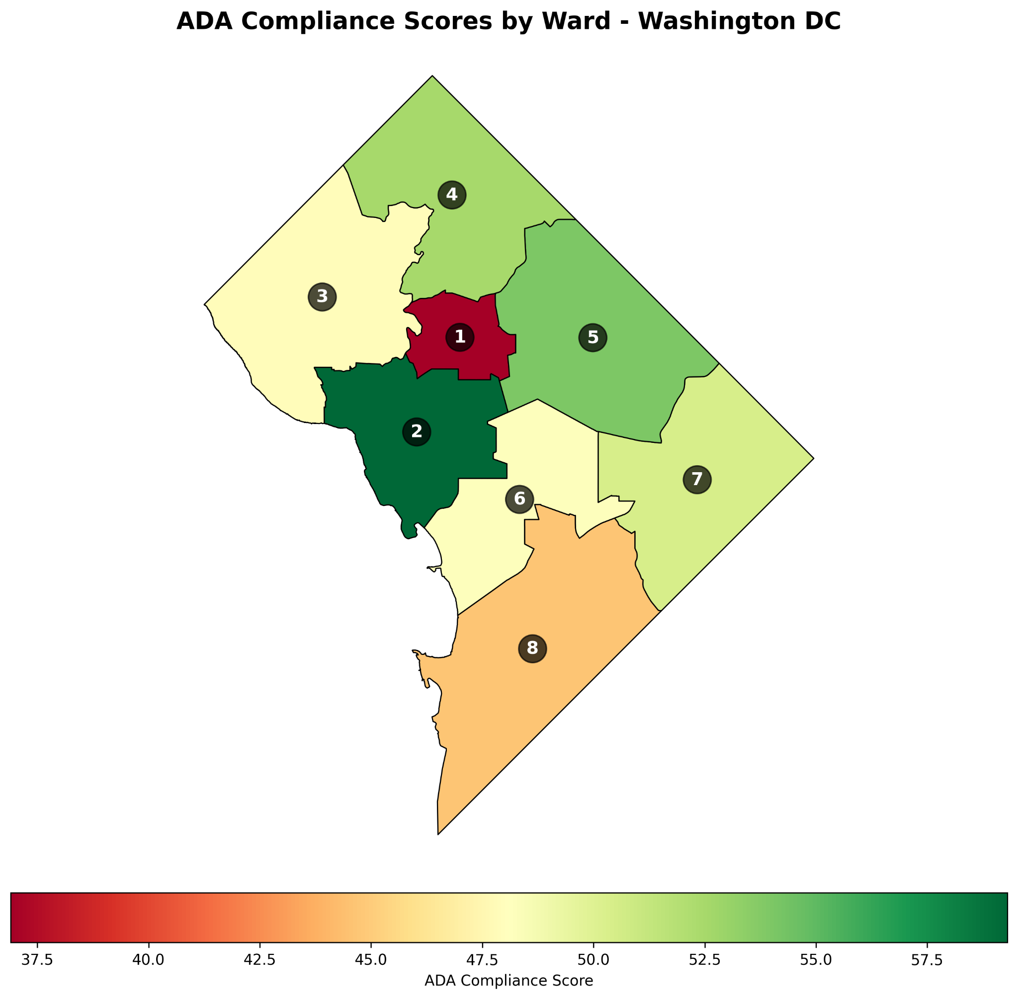

Figure 2: ADA Compliance Grades by Ward
The bar chart below visualizes the Final Score from Table 1. The dashed lines represent grade thresholds (A = 90, B = 80, C = 70, D = 60, but I used a more realistic scale given the data). Every ward falls within the C or D range. No ward reaches a B.

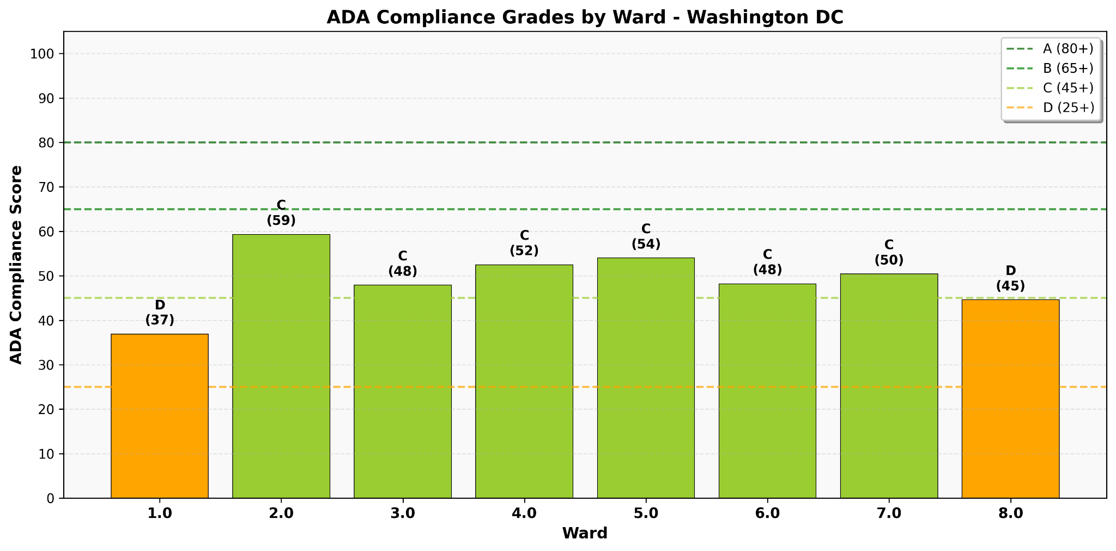

Distance and Barrier Findings
In addition to the scoring system, I calculated two other critical outputs. First, the median distance from a ward centroid to the nearest ADA-compliant bus stop ranges from approximately 60 meters to over 300 meters. For a person with ambulatory limitations, this extra distance converts a feasible walk into a barrier. Second, the median distance to the nearest high-impact barrier (classified as NO SIDEWALK, VERTICAL DISPLACEMENT, POLE, or POOR WIDTH) is 199 meters (population-weighted). In plain language: you cannot go more than a couple of city blocks in Washington, D.C., without encountering a failed asset.
Value Provided
The value of this final data product is diagnostic and actionable. City planners can use the ward-level scores to prioritize repairs with equity in mind—directing resources to wards with high disability populations and low scores. Disability advocates can use the distance metrics to argue for specific transit improvements. The scoring system is transparent, reproducible, and based entirely on public data. This is not opinion; it is evidence.

6. References and Acknowledgments
References

- District Department of Transportation (DDOT). (n.d.). Accessible pedestrian signal. https://ddot.dc.gov/fr/node/1809716
- District Department of Transportation (DDOT). (n.d.). Americans with Disabilities Act - Equal access for people with disabilities - Title I - Title II - Title IV. https://ddot.dc.gov/fr/page/americans-disabilities-act-equal-access-people-disabilities-title-i-title-ii-title-iv
- District Department of Transportation (DDOT). (n.d.). Sidewalk Gap Program. https://sidewalkgap.ddot.dc.gov
- District of Columbia Open Data Portal. (2022). Wards from 2022 [Data set]. https://opendata.dc.gov/datasets/DCGIS::wards-from-2022/about
- District of Columbia Open Data Portal. (2024a). ADA audible pedestrian signals [Data set]. https://opendata.dc.gov/datasets/DDOT::ada-audible-pedestrian-signals/about
- District of Columbia Open Data Portal. (2024b). ADA barriers in the public right-of-way [Data set]. https://opendata.dc.gov/datasets/DDOT::ada-barriers-in-the-public-right-of-way/about
- District of Columbia Open Data Portal. (2024c). ADA bus stops [Data set]. https://opendata.dc.gov/datasets/DDOT::ada-bus-stop/about
- District of Columbia Open Data Portal. (2024d). ADA curb ramp [Data set]. https://opendata.dc.gov/datasets/DDOT::ada-curb-ramp/about
- District of Columbia Open Data Portal. (2024e). Sidewalk condition assessment [Data set]. https://opendata.dc.gov/datasets/DDOT::sidewalk-condition-assessment/about
- Metro (Washington Metropolitan Area Transit Authority) & Smart Growth America. (2015, October 9). All aboard for more accessible bus stops in greater Washington, DC. Smart Growth America. https://www.smartgrowthamerica.org/knowledge-hub/news/all-aboard-for-more-accessible-bus-stops-in-greater-washington-dc/
- U.S. Census Bureau. (2023). *ACS 5-year economic characteristics (Washington, D.C., by ward)*[Data set]. https://data.census.gov/table
- U.S. Census Bureau. (2023). *ACS 5-year social characteristics (Washington, D.C., by ward)* [Data set]. https://data.census.gov/table
- U.S. Department of Justice. (1990). Americans with Disabilities Act of 1990, Pub. L. No. 101-336, 104 Stat. 328.
- Washington Metropolitan Area Transit Authority (WMATA). (2024). Metro stations (regional) [Data set]. DC Geographic Information System (DC GIS). https://opendata.dc.gov/datasets/DCGIS::metro-stations-regional/about
- Additional dataset obtained through internal program survey (psm_11). (n.d.). [Data set].

Acknowledgments
I would like to thank my colleagues for their critical feedback, my friends and family for their patience, and Professor Perine for continuous guidance from start to finish. This project represents not just a grade, but a proof-of-concept that data science can be used to advocate for a more equitable urban environment.
I would like to thank Zachary Smith from the D.C. Department of Transportation (DDOT) for responding to my emails and corresponding with me to clarify several technical details about the ADA Inventory of Barriers system, including how assets are scored (1–4, from Non-Compliant to Good), the distinction between condition assessments based on visual inspection versus required measurements, and the existence of programs such as the Sidewalk Gap Program and the multiyear PaveDC sidewalk rehabilitation initiative.

